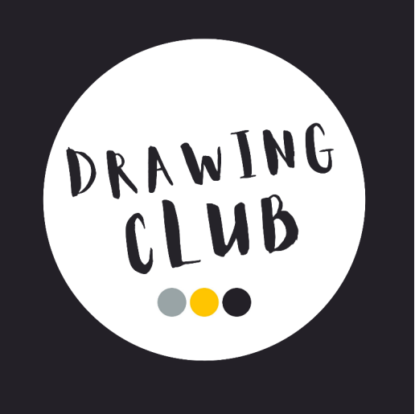

Writing in Year 1 – Our Drawing Club Approach
Our English lessons are inspired by the principles of Drawing Club, an approach originally developed by Greg Bottrill. Over time, we have adapted and developed this approach to meet the needs of our Year 1 children, creating an engaging and carefully structured writing curriculum that combines creativity with explicit teaching.
Our aim is to nurture confident, imaginative writers by placing high-quality stories at the heart of learning. Through exciting texts, daily vocabulary exploration and rich discussion, children develop vocabulary, oral language, fine motor skills, spelling, handwriting and sentence construction, while discovering that writing is an enjoyable way to communicate ideas.
How do we teach writing?
Each week begins with a carefully chosen high-quality picture book or non-fiction book. We select these to reflect children's interests, our curriculum topics, the changing seasons, celebrations and the diverse cultures, religions and backgrounds represented within our class.
Together we explore the text by discussing the front cover, title and illustrations before making predictions. We talk about characters, settings and events, sequence the story and consider how authors create meaning. These discussions provide children with the language and confidence they need before they begin writing.
Developing Vocabulary
Vocabulary development is central to our writing approach. Each day, children are introduced to a new selection of ambitious "Wow Words" linked to that day’s character, setting or adventure focus. These carefully selected words often extend beyond the vocabulary found within the text itself and are chosen to inspire curiosity and enrich children's language.
We introduce each word with enthusiasm, actions and discussion, encouraging children to use the new vocabulary in their speaking and writing. As the focus changes from character, to setting, to new adventures, children encounter a wide range of descriptive and expressive vocabulary across the week.
Previously introduced vocabulary remains available for children to revisit and use independently. As children's writing develops across the year, we gradually reduce the level of explicit vocabulary support to allow greater time for composing, writing and editing independently.

Our Weekly Writing Journey
Each week follows a familiar structure that builds confidence whilst allowing plenty of opportunity for imagination.
Monday – Character Focus
Children explore a character from the story, discussing appearance, personality and feelings before developing descriptive vocabulary.
Tuesday – Setting Focus
Children draw and describe the setting and may imagine how it could change. A forest may become enchanted, a castle may appear from nowhere or a river may suddenly part to reveal a hidden path. We encourage children to ask, "What if...?"
Wednesday and Thursday – The Adventure Begins!
This is where creativity takes over. Children change parts of the original story, solve problems, create new endings and invent exciting adventures. Anything is possible when imagination leads the learning.
Throughout the week, children draw, talk, rehearse and write, gradually becoming more independent as their confidence grows.
Teaching Writing Explicitly
Whilst creativity is at the heart of our approach, writing skills are taught explicitly every day.
We use an "I can, We can, You can" model to support children through the writing process.
The teacher first models how to compose a sentence linked to their drawing, thinking aloud about vocabulary, sentence structure and punctuation. Together, the class rehearses the sentence orally several times whilst counting each word on their fingers. Children then help segment words for spelling, discussing capital letters, finger spaces and punctuation before editing the sentence together.
Children initially copy the modelled sentence onto their whiteboards before working collaboratively with the teacher to compose a second sentence using the same structure which is written in their books. Adults provide immediate, verbal feedback and support before children move on to writing their own independent sentence in their book.
This carefully scaffolded approach gives children repeated opportunities to practise sentence structure, spelling and punctuation, allowing them to become increasingly confident, independent writers who can focus on making their writing interesting rather than simply remembering how to write a sentence.
As the year progresses, the first sentence written on whiteboards is dropped, to allow children longer to compose, write and edit their own sentence.
Progressive Writing Skills
Each half term, we focus on one key writing skill so that children have time to revisit, practise and embed their learning.
• Autumn Term – Writing simple sentences with capital letters, finger spaces and full stops. Children begin learning how to edit and improve their work using green pen and editing stampers.
• Spring 1 – Using adjectives to add detail and commas to separate adjectives in lists.
• Spring 2 – Writing questions and exclamations using the correct punctuation.
• Summer Term – Writing with increasing stamina, extending ideas using conjunctions such as and, but and because.
Throughout the year, children are also introduced to grammar through meaningful contexts. We regularly discuss nouns, adjectives and verbs, encouraging children to identify and use these word classes confidently within their own writing.
By focusing on one key learning intention over many consecutive weeks, children are able to develop a deeper understanding before applying their new skills independently across a range of writing opportunities.
Feedback and Assessment
Adults work alongside children throughout every lesson, providing immediate, verbal feedback and guidance as they write. This enables misconceptions to be addressed instantly and allows children to edit and improve their work as part of the writing process.
Our approach values progress over perfection. We celebrate ideas, imagination and resilience, while supporting every child to become an enthusiastic, confident writer who is proud of what they have achieved.

