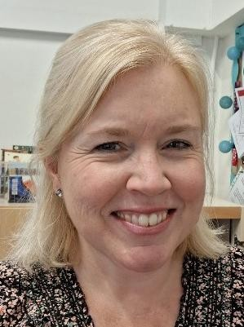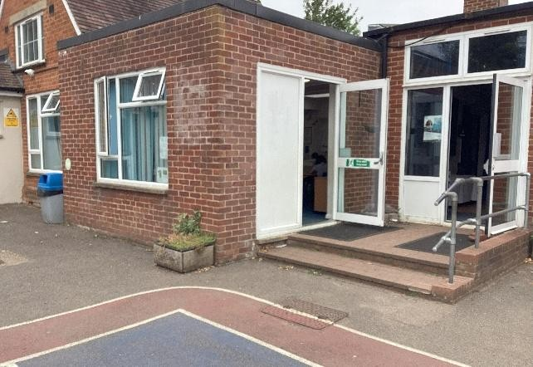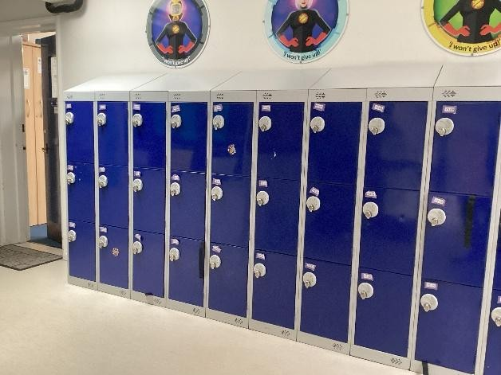
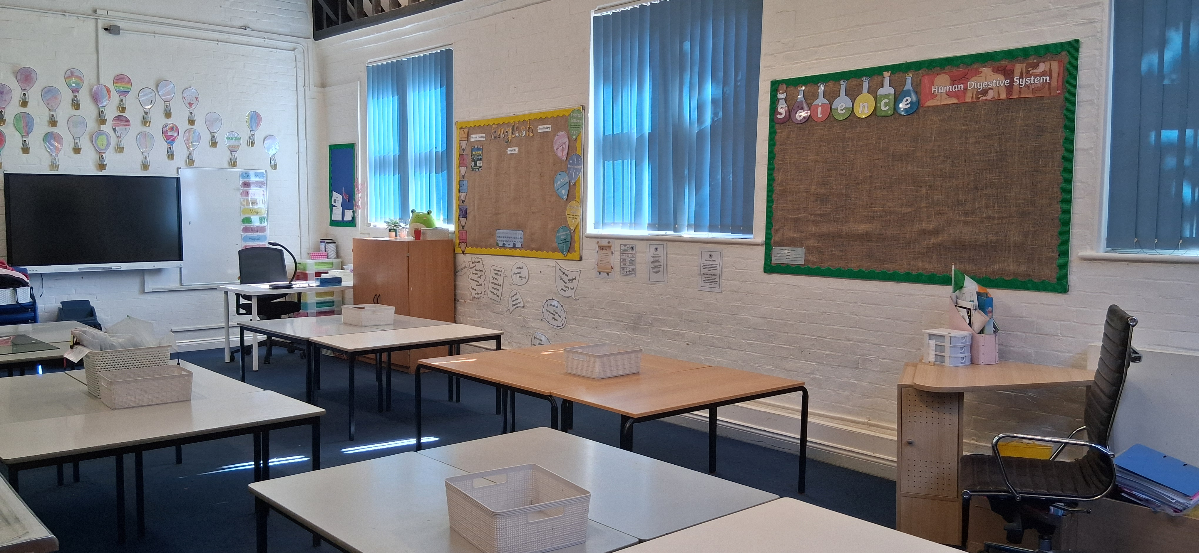

This is our classroom.

Moving into Year
4

2026
6/27

The class teachers
’

name
s

are
:

Mrs Miller
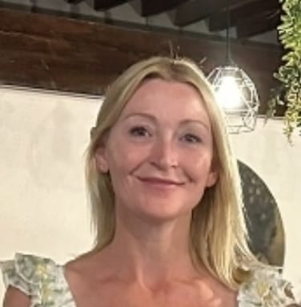

Mrs Donnelly

Our Y
4

Teaching
A
ssistant
s

will be
:

Mrs Davies-Golder

Miss Stallard
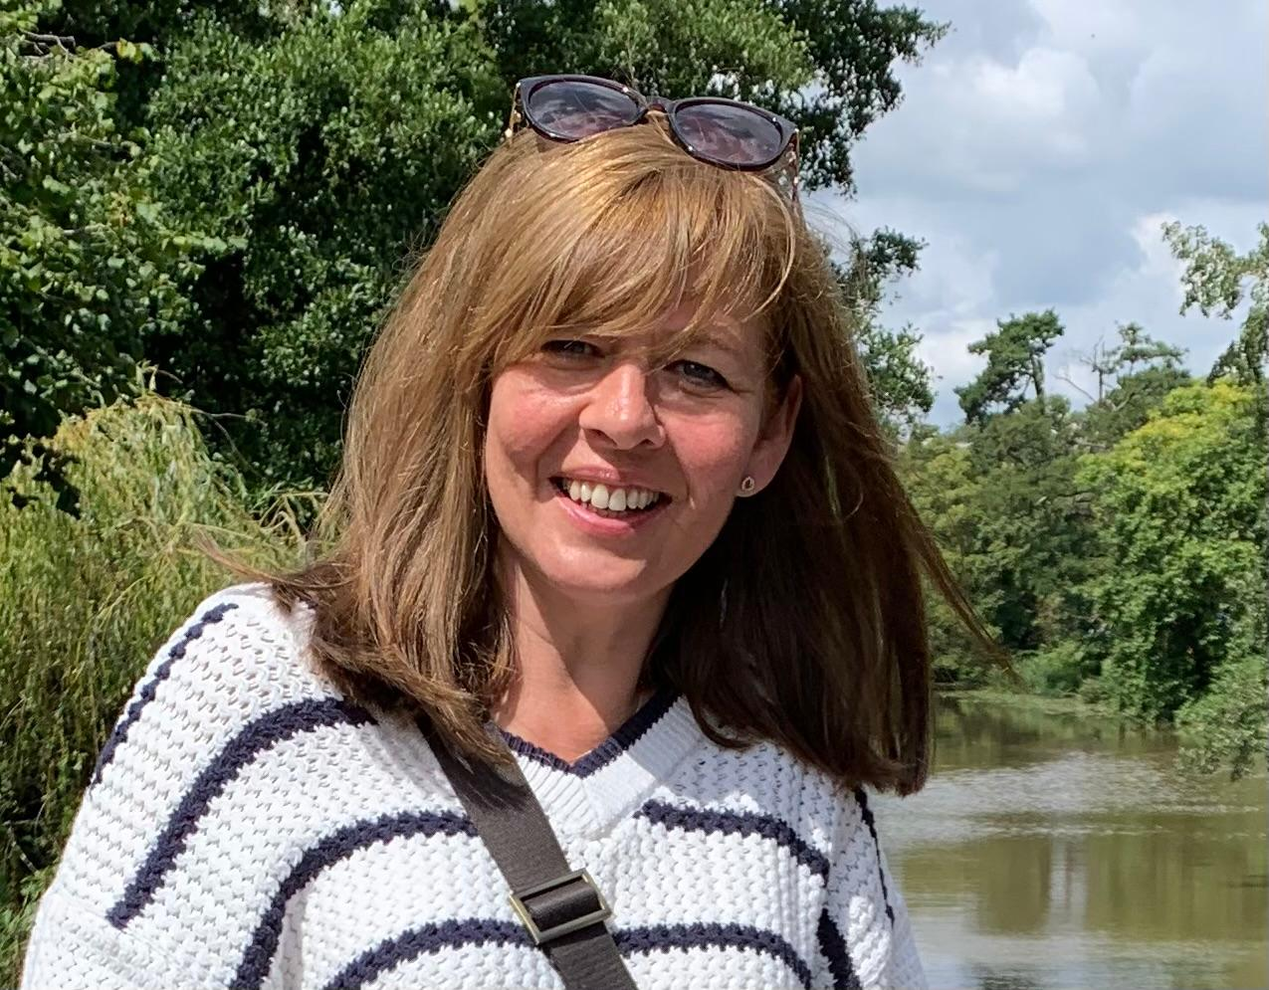



This is where you will
come into
school each day
.

You will have your locker for your
coat,

PE bag and personal things.

In

Our curriculum themes for Autumn 1 are:
English: Surprise book!
Maths: Place value, Addition and Subtraction.
Science: Animals including Humans.
Geography/History: TBC
RE: Christianity – What is the Trinity?
PHSE: Being me in my world.
PE: Football and Floor Gymnastics.
Spanish: Phonetics.
Music: Pentatonic scale.
Art/D + T: William Morris /Pencil cases
Computing: The internet.

